SIMULATION TASK

NAME: V Sadhana

REG NO: 192412242

COURSE NAME AND CODE: 5G 6G Communication – ECA5604

1. LTE OFDM vs 5G NR

Aim
Simulation of waveform comparison between LTE OFDM and 5G NR under PAPR, BER, bandwidth, latency and spectral efficiency.

MATLAB Code
clc; clear; close all;
bw=10:10:100;
LTE=2+0.04*bw;
NR=3+0.06*bw;
plot(bw,LTE,'-o','LineWidth',2); hold on;
plot(bw,NR,'-s','LineWidth',2);
xlabel('Bandwidth (MHz)');
ylabel('Spectral Efficiency (bps/Hz)');
title('LTE OFDM vs 5G NR');
legend('LTE OFDM','5G NR'); grid on;

Output
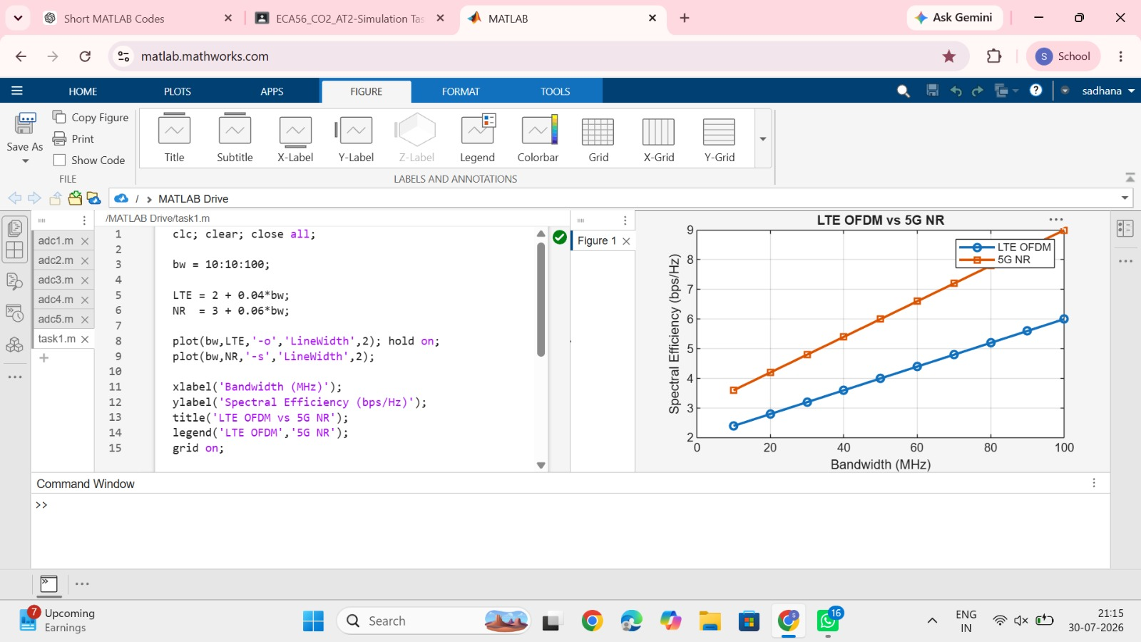

Result
The graph shows that 5G NR provides higher spectral efficiency than LTE OFDM as bandwidth increases.

2. gNodeB Traffic Handling

Aim
Simulation of gNodeB traffic handling under user density.

MATLAB Code
clc; clear; close all;
users=10:10:200;
throughput=1000-2*users;
plot(users,throughput,'b-o','LineWidth',2);
xlabel('Users'); ylabel('Throughput (Mbps)');
title('gNodeB Traffic Handling'); grid on;

Output
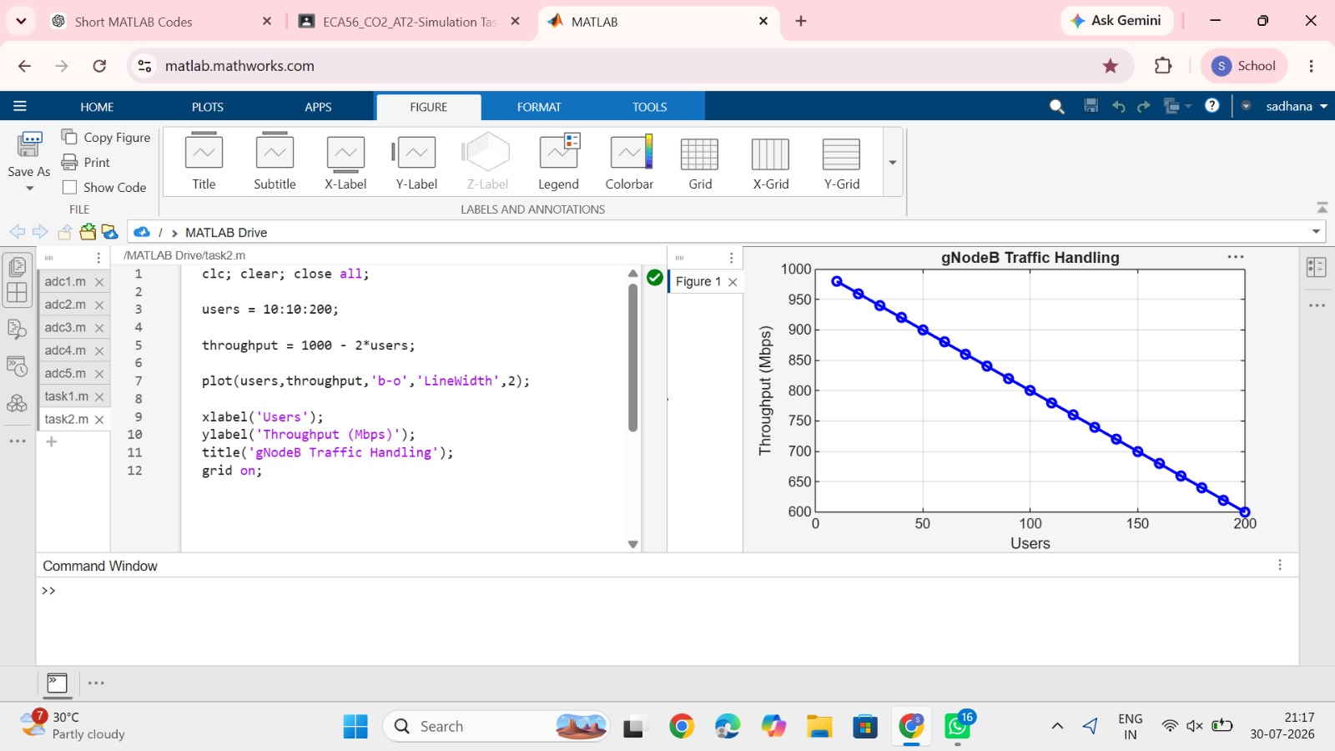

Result
Throughput decreases gradually as the number of users increases.

3. Functional Split in 5G RAN

Aim
Simulation of functional split under processing delay.

MATLAB Code
clc; clear; close all;
split=1:7;
delay=[2 3 5 7 9 12 15];
plot(split,delay,'r-*','LineWidth',2);
xlabel('Functional Split Option');
ylabel('Processing Delay (ms)');
title('5G RAN Functional Split'); grid on;

Output
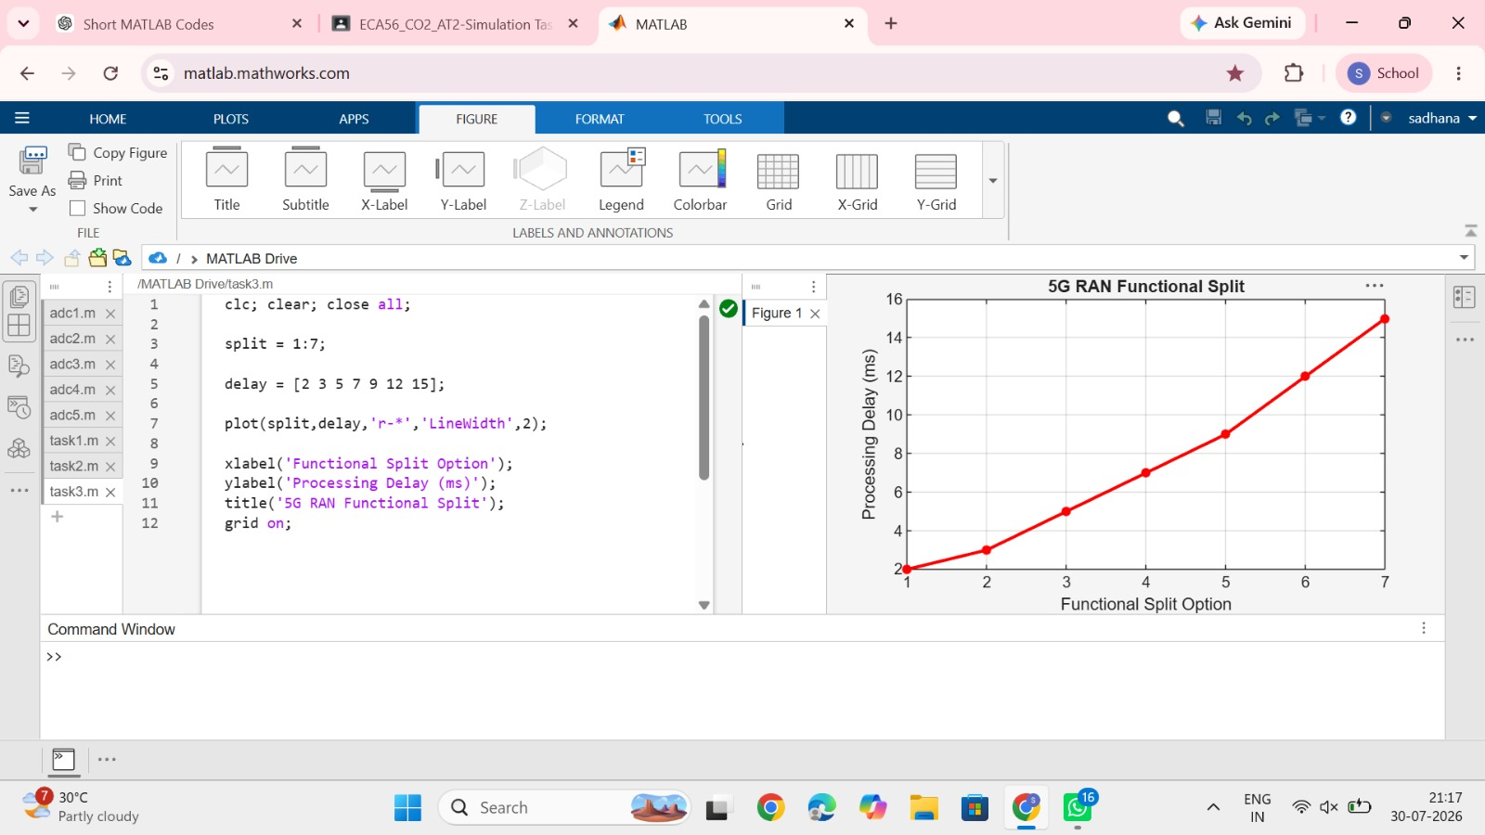

Result
Processing delay increases with higher functional split options.

4. RRC Procedure Timing

Aim
Simulation of RRC procedure timing under handover delay.

MATLAB Code
clc; clear; close all;
handover=5:5:50;
setup=20+0.5*handover;
plot(handover,setup,'m-s','LineWidth',2);
xlabel('Handover Delay (ms)');
ylabel('Connection Setup Time (ms)');
title('RRC Procedure Timing'); grid on;

Output
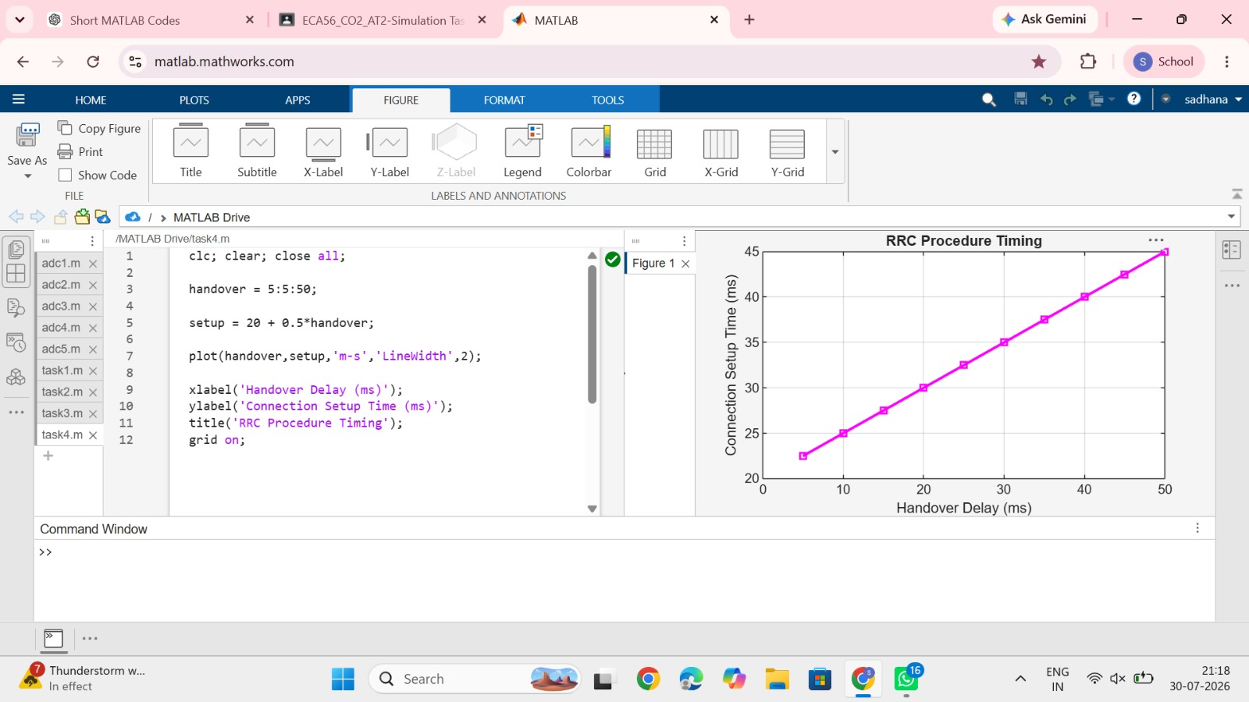

Result
Connection setup time increases with handover delay.

5. Service-Based Architecture

Aim
Simulation of service-based architecture under session count.

MATLAB Code
clc; clear; close all;
session=100:100:1000;
throughput=1000-0.4*session;
plot(session,throughput,'g-o','LineWidth',2);
xlabel('Session Count');
ylabel('UPF Throughput (Mbps)');
title('Service-Based Architecture'); grid on;

Output
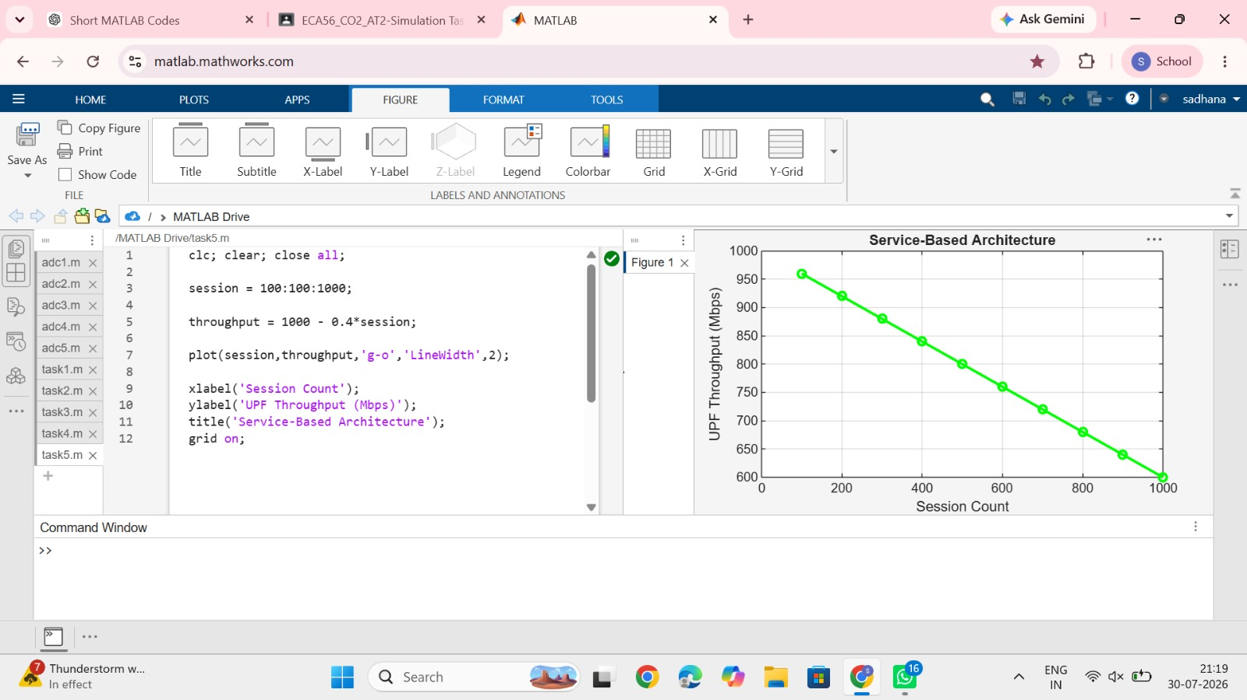

Result
UPF throughput decreases as the number of sessions increases.

